|  |  |
| --- | --- |
|  | **DOKUZ EYLÜL UNIVERSITY**  **ENGINEERING FACULTY**  **DEPT. OF COMPUTER ENGINEERING** |

Online Game Store

# CME 3201 Database Management Systems

# Term Project Report

Phase II

2019-2020 FALL

2015510035 Berke KADAM

2400000145 Mehmet Hamdi USLU

## Detailed System Design

### Entity-Relationship Diagram

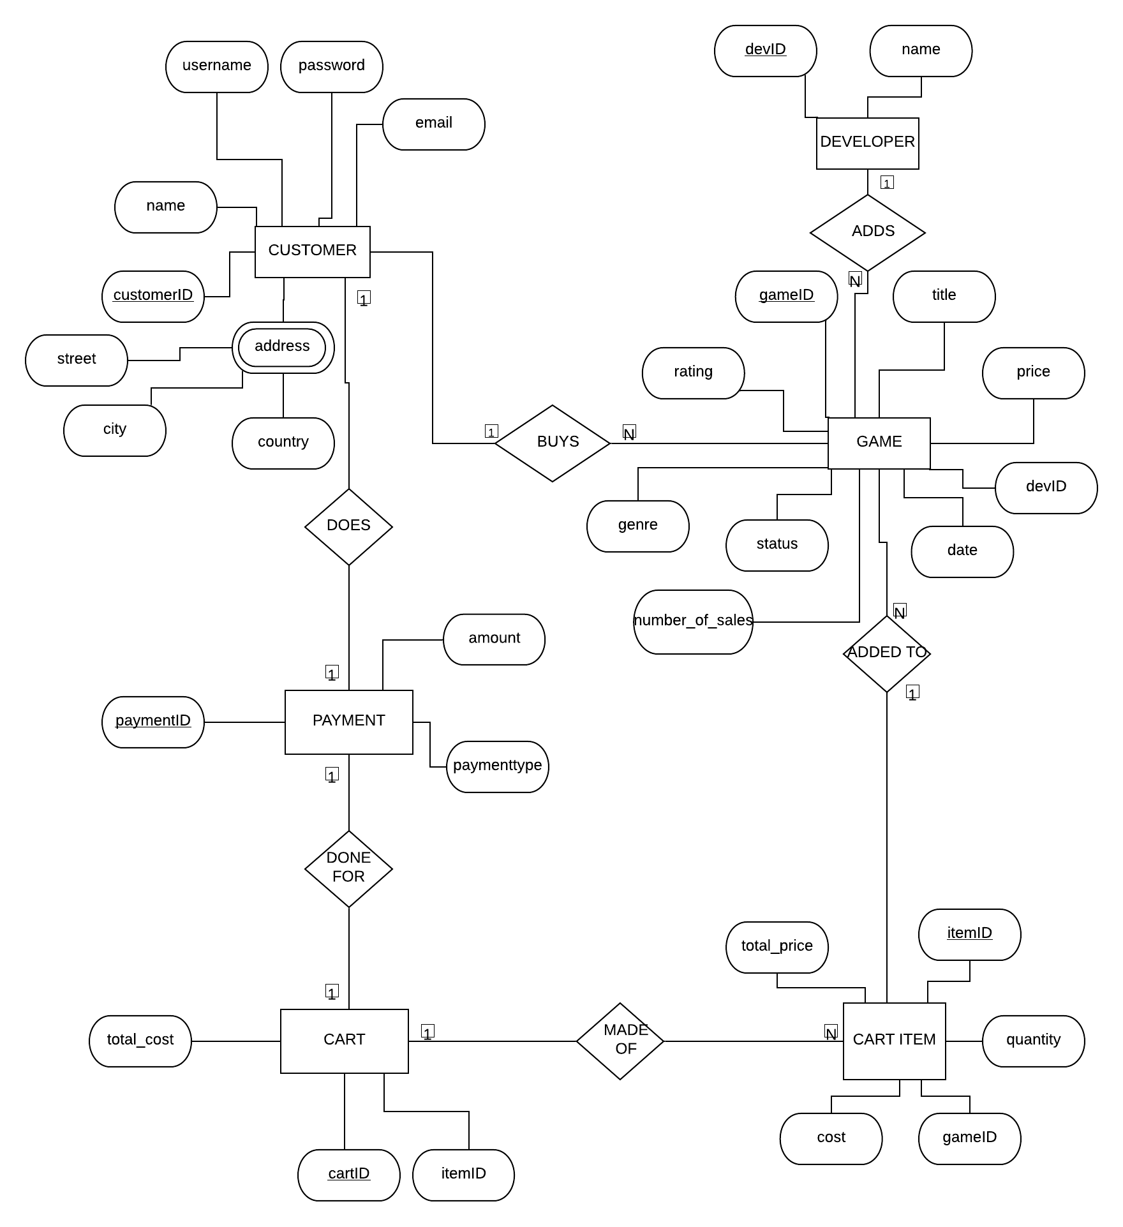

### Relational Algebra Expressions

SELECT G.Title, G.Price AS PriceList,

FROM Game G,

WHERE G.Price = 100

**π title, price (σ price=1005 (Game))**

SELECT G.Title,

FROM Developers D

INNER JOIN Games G ON D.DevID = G.DevID

WHERE D.DevName = ‘EA GAMES’

ORDER BY G.Title

**π title (σ DevID=’EA Games’ (Developer) ⨝Developer.DevID = Game.GameID Games)**

SELECT G.Title,

FROM Game G,

GROUP BY G.GameID

HAVING G.Rating > 70

**π title (σ rating > 70 (Game))**

SELECT G.Title,

FROM Game G,

WHERE G.Price > 100 AND Release Date < 2019

ORDER BY G.ReleaseDate ASC

**π title (σ price > 100 ^ release date < 2019 (Game))**

SELECT D.Name, AVG(G.Rating),

FROM Game G,

INNER JOIN Developers D ON D.DevID = G.DevID,

GROUP BY D.Name,

ORDER BY D.Name

**π developer.name** (**σ avg(rating)((σ devName (Developer) ⨝ Developer.DevID = Game.DevID Game)))**

### Class Diagram

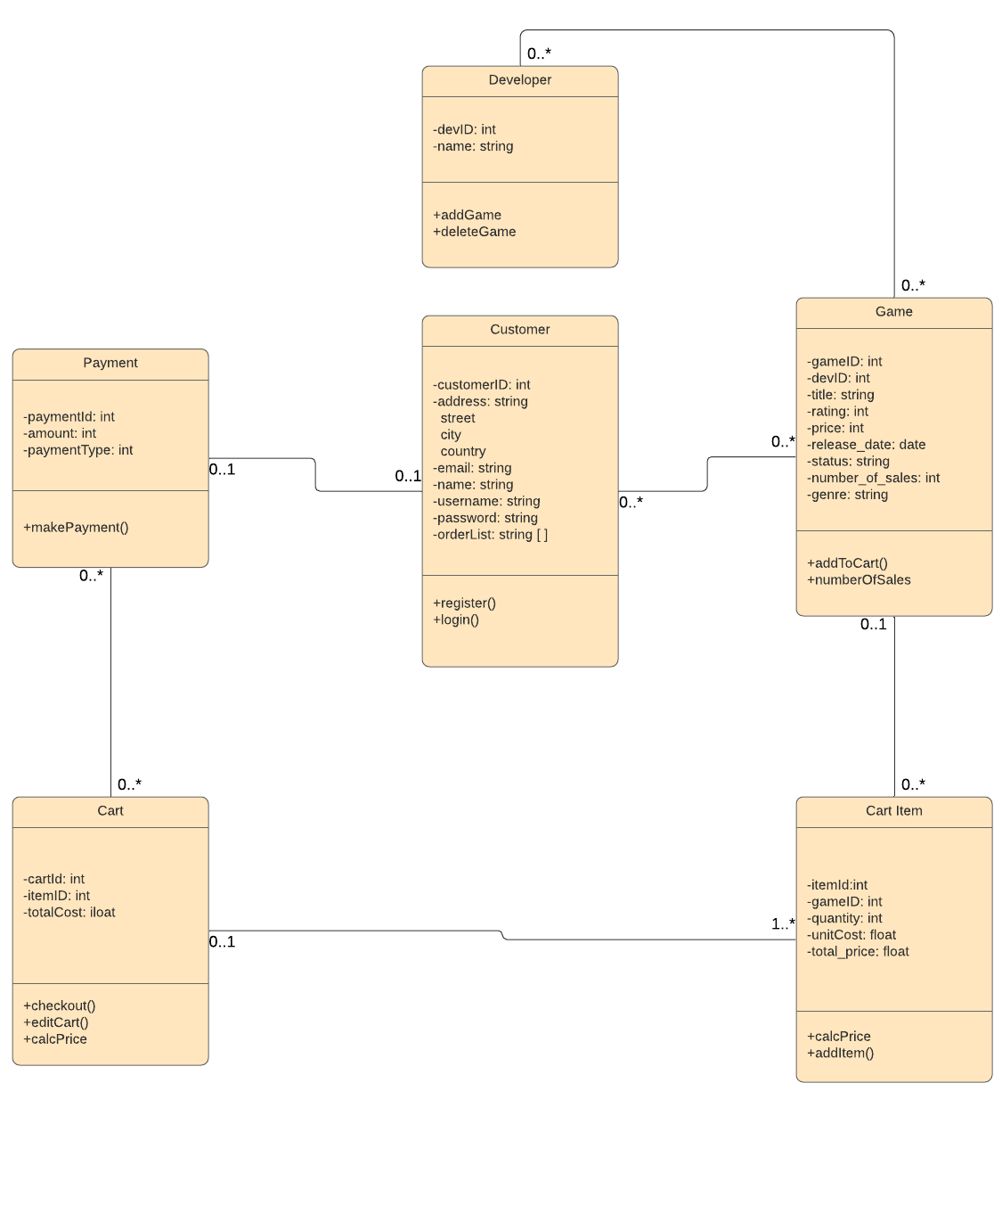

### CRUD Matrix

For User

|  |  |  |  |  |
| --- | --- | --- | --- | --- |
| **Relations\Operations** | **Create** | **Read** | **Update** | **Delete** |
| Game |  | X |  |  |
| Cart | X | X | X | X |
| CartItem |  | X |  |  |

For Store Admin

|  |  |  |  |  |
| --- | --- | --- | --- | --- |
| **Relations\Operations** | **Create** | **Read** | **Update** | **Delete** |
| Game | X | X | X | X |
| Cart |  | X |  |  |
| Customer |  | X | X | X |

For Developer

|  |  |  |  |  |
| --- | --- | --- | --- | --- |
| **Relations\Operations** | **Create** | **Read** | **Update** | **Delete** |
| Game | X | X | X | X |